Activity: Sunlight Throughout the Year

Introduction

All weather and climate begin with the Sun. Solar radiation is the only significant source of energy that determines conditions at and above Earth’s surface. Earth receives about 1/2,000,000,000 of the Sun’s radiant energy production.

The average amount of solar radiation reaching Earth’s orbit (top of the atmosphere) and falling on a flat surface perpendicular to the Sun’s rays at that distance is about 2 calories per square centimeter per minute. This rate is called the solar constant.

However, the amount of solar radiation that reaches the Earth's surface can be quite different. The nearly-spherical Earth, rotating once a day on an axis inclined as it is to the plane of its orbit, presents a constantly changing face to the Sun. Everywhere on Earth the path of the Sun through the sky changes during the year. Everywhere on Earth, except at the Equator, the lengths of daily daylight periods change.

In addition, the atmosphere acts to reflect, absorb, and scatter the solar radiation passing through it. Clouds, especially, can reflect and scatter much of the incoming radiation.

The purpose of the activity is to investigate the variability of sunlight received at Earth’s surface over the period of a year.

Upon completing this activity, you should be able to:

- Investigate the receipt of solar energy over the period of a year at equatorial, mid-latitude, and polar regions.

- Describe annual solar radiation patterns at different locations and relate then to the astronomical factors that cause them.

- Estimate and compare average daily radiant energy totals received at a mid- latitude location on the first days of the seasons.

Procedure

Examine the accompanying graph entitled Variation of Solar Radiation Received on Horizontal Surfaces at Different Latitudes. Data points plotted on the graph represent solar radiation received daily on horizontal surfaces averaged over each month for equatorial, mid-latitude, and polar locations. These values were determined from actual observations and include the effects of clouds. Time is

©American Meteorological Society

plotted along the horizontal axis while average daily incident radiant energy in calories per square centimeter per day is plotted vertically.

Questions

- Construct an annual solar radiation curve for each of the three locations. Do this by drawing a smooth curved line connecting adjacent months of average daily radiation values for the locations that have already been plotted. Note that at the South Pole (90 degrees South Latitude) the Sun rises on or about September 23 and sets on or about March 21. Draw each curve to the edges of the graph. December appears twice to more clearly display the annually repeating radiation cycles.

- At which latitude shown does the rate at which solar energy is received vary the least throughout the year?

- The annual radiation curve for Singapore shows two maxima and two minima even though the daily period of daylight remains nearly 12 hours throughout the year. Explain the astronomical cause of the two maxima and minima by referring to Fig. 2(a) in the Sunlight and Seasons diagram.

- Refer to Fig. 2(b) in the Sunlight and Seasons diagram. At such a middle latitude location, both the path of the sun through the sky and the daily length of daylight change from day to day. Use these two factors to explain why during the May-August period the mid-latitude location receives more solar radiation on a daily than does the equatorial location.

- Refer to your graph. At which latitude is there an extended period of
darkness over the year? How long is it?

- On your graph, the maximum daily solar radiation amount for Brockport occurred in late June. Why does it peak six months later at Antarctica?

- Draw and label an estimated annual solar radiation curve for the North Pole. Assume North and South Pole radiation values to be the same, but reversed,

over the period of a year. Fill in the North Pole (NP) column of the radiation table and then draw the North Pole curve.

- Imagine you are the observer in Fig. 2(c) of the Sunlight and Seasons diagram. Explain in terms of the path of the Sun and the daily period of daylight, the placement of your North Pole annual radiation curve.

- Compare all the annual radiation curves. What is the relationship between latitude and the annual range of solar radiation received?

- To mark the positions of the equinoxes and solstices, draw vertical lines on the graph at approximately March 21, June 21, September 23, and December
21. On the Equinoxes, the Sun is directly above the equator. while on the solstices the Sun is directly above 23.5 degrees North or South Latitude. Label the intervals between the lines as the Northern Hemisphere's Winter, Spring, Summer, and Fall seasons.

- The area enclosed under each curve between respective dates is directly proportional to the total energy received during that time period. At which location do all the seasons receive about the same total amount of solar radiation?

- At the mid-latitude location, which season(s) receive the most solar energy?
Which receive the least?

- At the North Pole, which season(s) receive no solar radiation at all?

- Calculate the annual amount of solar radiation received at the three locations. The equatorial and mid-latitude locations receive how many times more solar energy than either pole?

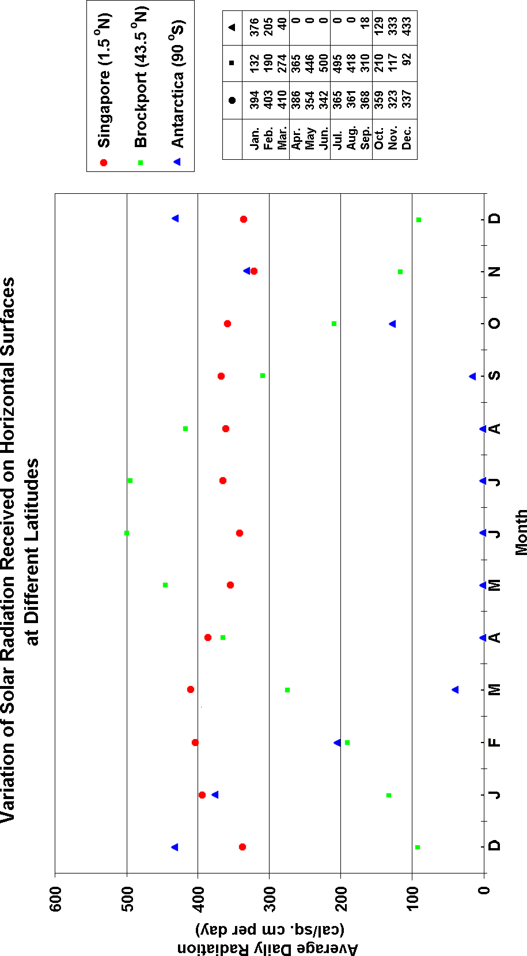

Real World Applications
The following maps are based on data collected from 1961 – 1990 in the National Solar Radiation Database. These are considered for the use of implementing flat plate solar collectors. The data can be listed or mapped as either the average, maximum or minimum monthly or annual values for a variety of solar collector geometries. The map choices came from: http://rredc.nrel.gov/solar/old_data/nsrdb/1961-1990/redbook/atlas/. These data account for both the astronomical and atmospheric factors at the locations shown. Dots indicate the stations providing the data at these generally mid- latitude locations.

- In general, the maximum monthly average solar radiation values occur in
. The minimum values are in .

- The values for March [(are)(are not)] generally comparable to those of September at the same locations.

- The solar radiation values across the country in December and in March [(do)(do not)] generally run parallel to the latitudes, and [(decrease) (remain the same)(increase)] as the latitude increases.

- Average monthly solar radiation values in June show a pattern of locally highest values in the U.S. desert Southwest. These higher values [(would)(would not)] likely be the result of atmospheric factors. That variation would most probably be due to the relative minimum of atmospheric [(water vapor)(clouds)(both of these)].

